**Name (As per class register): Goh Bo Jun, Issac (Wu Bojun)**

**Tutorial Group No.: T60**

**Name of Current Tutor (as of Week 13): Ms Han I-Chia, Athena**

**Number of Words (excluding in-text citation, paragraph headers, and reference list): 1039**

**First Cycle:**

The transition from an army lifestyle with regimentation at its core over to the university student lifestyle has been drastic. The change resulted in an unusual amount of stress that has been placed on me, especially due to the difference in academic rigour compared to junior college. Currently, I am facing just first degree burnout as I am only failing to keep up, especially in physical activities that I used to partake in such as jogging and weight training to maintain physical health(Ho, 2023) Thus, currently, I feel that I am in the languishing quadrant as I face low mental health but low mental illness(Ho, 2023). I have seemingly decided to forgo such physical activities in exchange to rushing off deadlines, working harder and longer on the academic aspect of my life. This shows that I have been adopting a form of maladaptive coping behaviour by working longer and harder at a disregard of my own wellbeing(Ho, 2023).

Therefore, I will attempt to adopt a more positive coping strategy through problem-focused coping(Ho, 2023). This will be through my attempts to adopt a weekly regiment of exercising at least 3 times a week either cardiovascular or weight training. During every cycle, I will be implementing such a workout routine for a month before evaluating the effectiveness of it. For the first cycle, I have set aside a time of 1.5 hours every monday, wednesday and friday to partake in the physical activities.

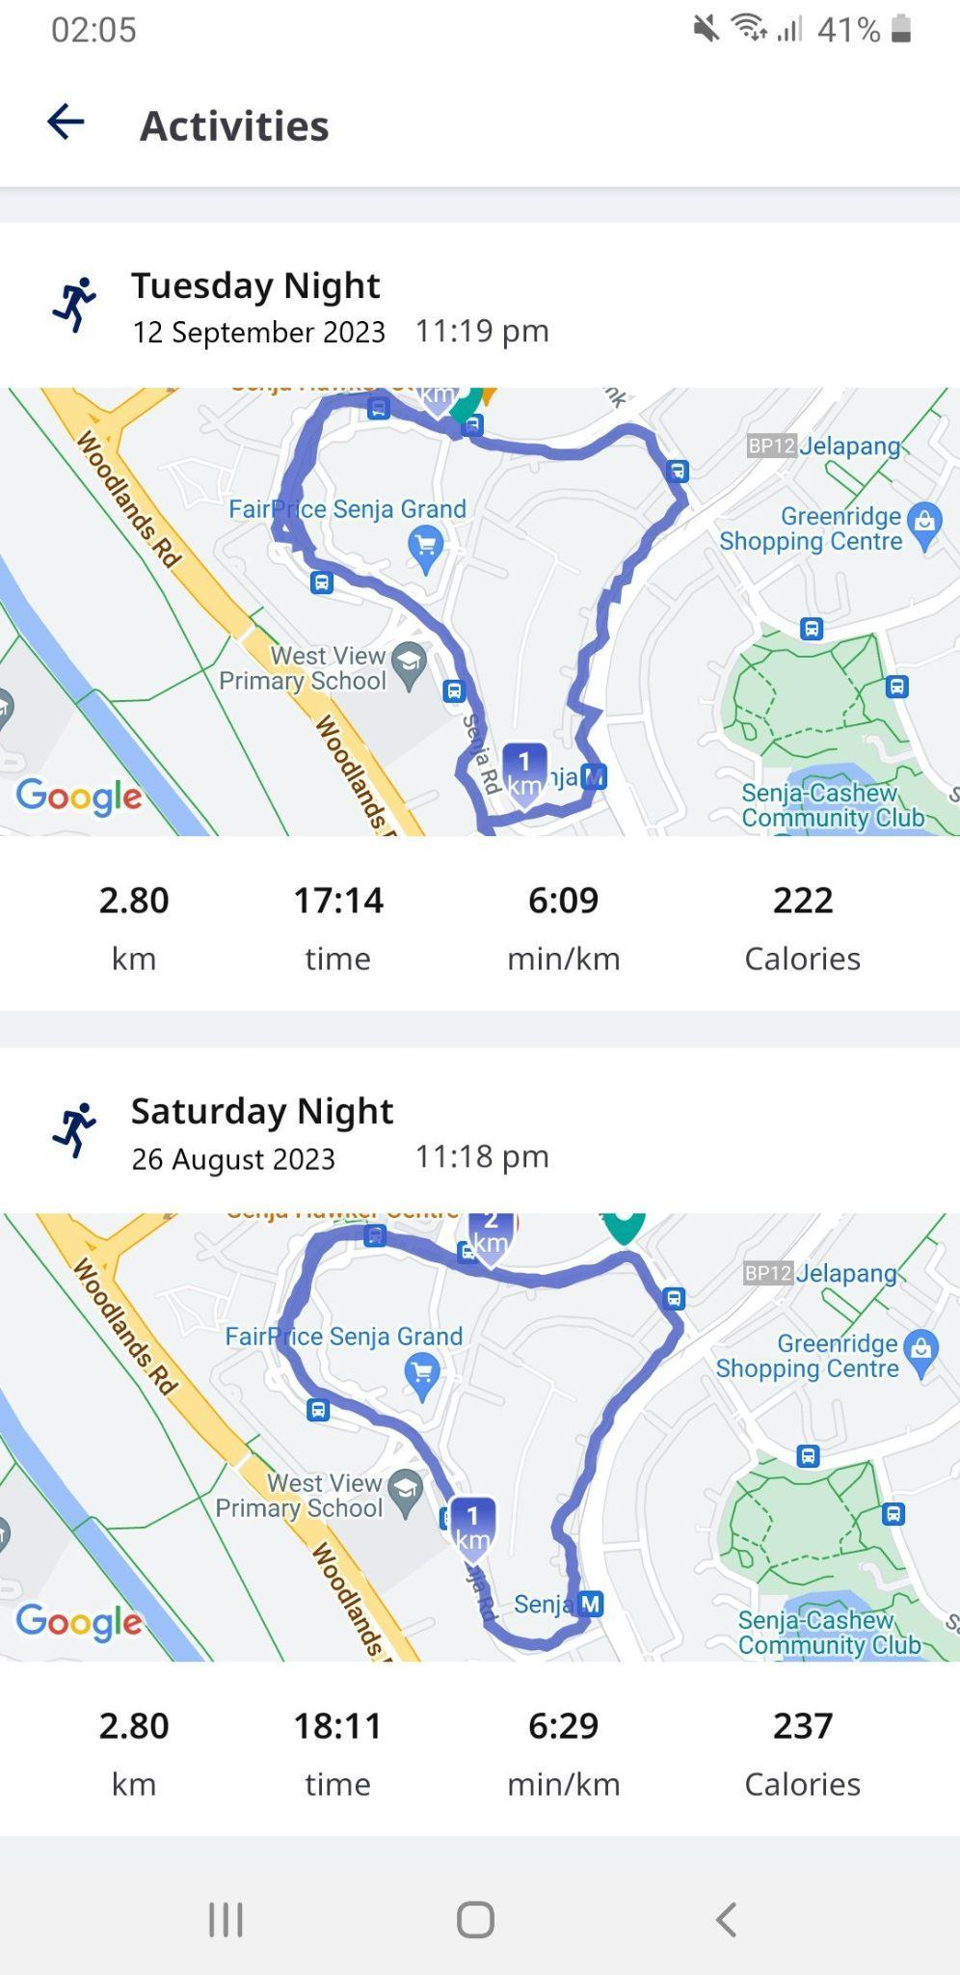

After the first 2 weeks, I realised that due to the time span between the last time I exercised, I experienced severe delayed onset muscle soreness (DOMS) and could not viably carry out the planned thrice a week regiment. Furthermore, it was awkward to try to fit in the exercise schedule with the usual studying plan I have set in stone since the beginning of university.For the following 2 weeks until the end of the month, I was still exercising much less than thrice a week as it was nearing midterms and I shifted my priority onto academics than my well being.

Looking back on my lacklustre performance for the month, it was disappointing and I had the notions of giving up on the goal at hand. I was also blaming the circumstance of the heavy workload towards the end of the month for not achieving the goal and not looking at the root cause. This shows a fear of success as I was trying to strive for perfection from the get go and I realised that my true motivation for taking such a goal was extrinsic to complete this assignment. I believed that my circumstances were under an external locus of control where external factors and circumstances were the large influence of my choices.Thus, I restructured my thinking to instead look at the goal as a way to improve my physical health.

**Second Cycle:**

I decided to make my habits more obvious by placing my workout clothes on my bed before leaving for school. This can help ensure that when I return home from school, I am reminded of my obligation and can ensure that I have a higher chance of sticking to my routine. Furthermore, I have decided to place my showering schedule to be after my exercise to further incentivise my action to exercise(Tay, 2023). I will also adopt a more proactive coping approach where I identify any threats to my routine in advance so that I will not be as surprised and have a backup plan where I exercise on the weekends should I miss any during the weekdays.Furthermore, I will practise more self-care as the root cause of the problem of me not exercising is due to me stressing too much on my academics. I will do this by bouldering on the weekends and this can also help to clear my physical activity for the week.

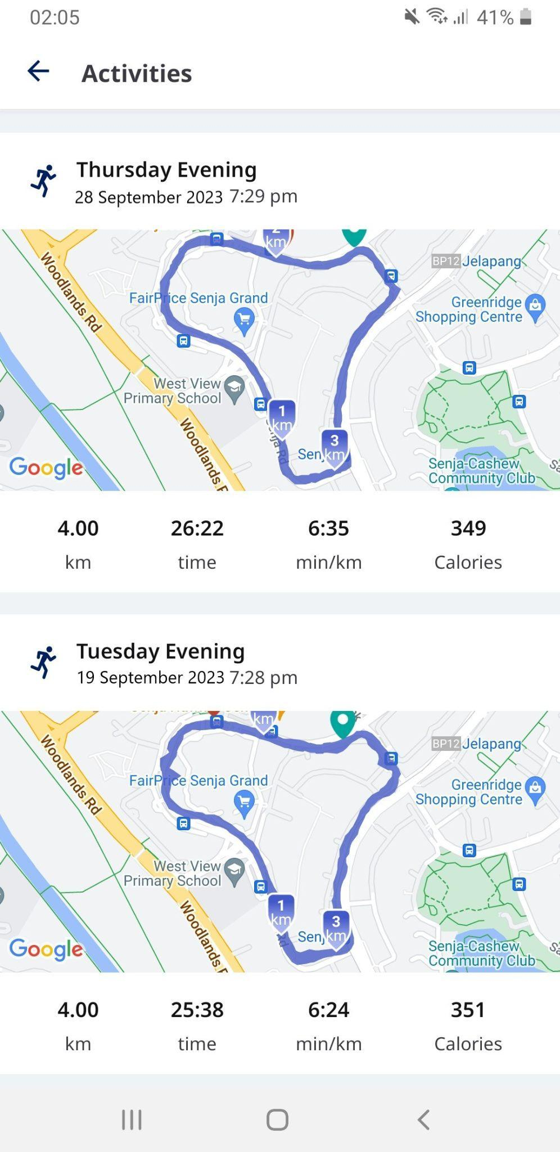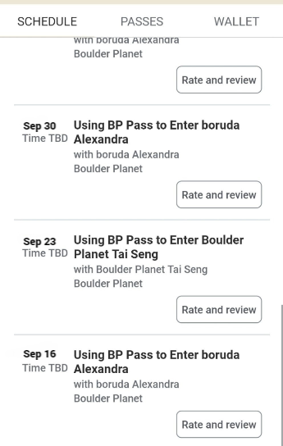

During this month, I realised that my activity of bouldering was multifaceted in solving my problems.Firstly, it helped to relieve my stress as I practise self-care and clear my criteria for physical activity for the week. Furthermore, since I climbed with my friends, the fostering of healthy relationships also helped to reduce stress by lowering cortisol production and gave me a sense of belonging.(Ho, 2023) This also helped to reinforce the habit of attending the bouldering sessions even when there is a lack of motivation as I had a promise to be upheld to my friends.

**Third Cycle:**

Following the previous month, I decided to maintain the semi structured format of exercise. However, at the same time I decided to replace some of the weight training exercises with mobility focused exercises. After learning about how the DALYS in Singapore is increasing, I remembered about the rehabilitation exercises I was doing when I was injured during the army.(Tay, 2023) The rehabilitation exercises, although seemingly easy, helped to strengthen my ligaments and tendons at a more comfortable pace especially for my injured self. Thus, I had a renewed interest in such exercises and chose to incorporate them into my training regiment.

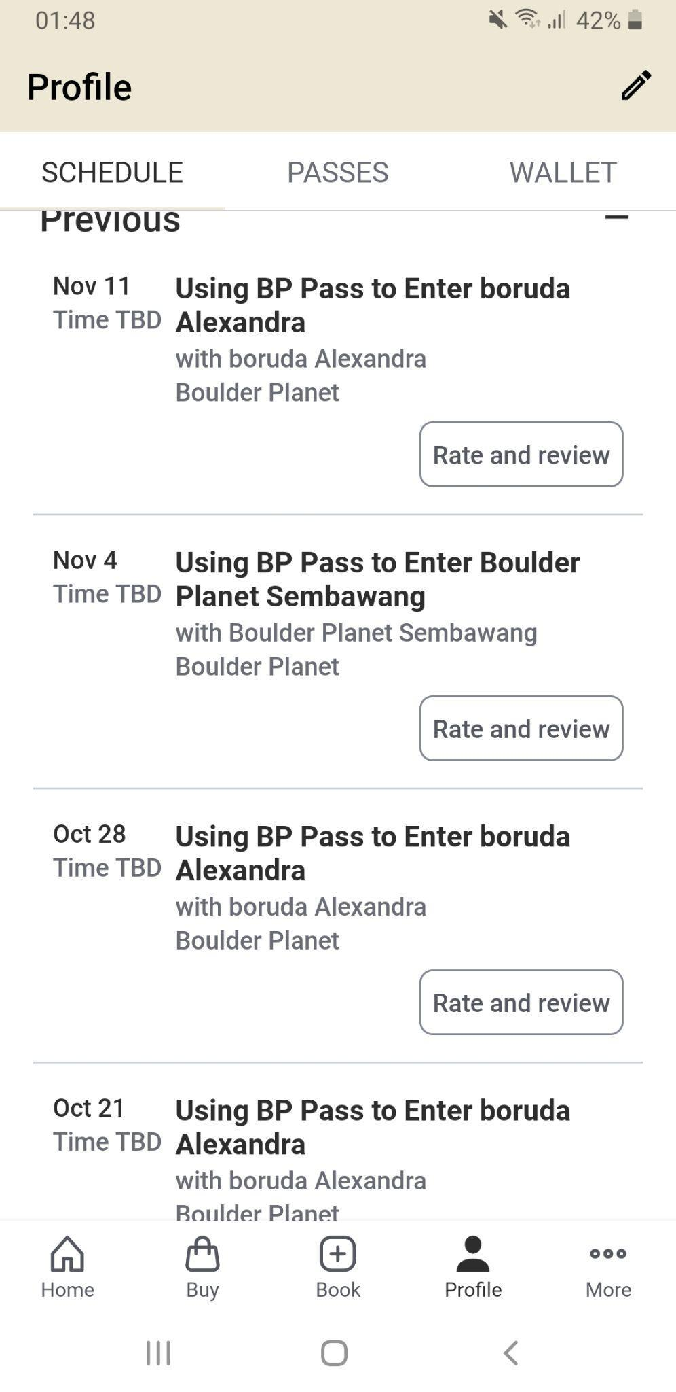

During this last month, although I only made some micro adjustments, I still could feel both my mental health and physical health improving though not as drastic as the previous month. Furthermore, it took even less effort to maintain the habits as the rehabilitation exercises helped to promote active recovery and placed lesser physical strain onto my body. I also felt that the motivation to keep up with the exercises is now intrinsic. This may be due to the feeling of pure enjoyment from being able to improve both my running distance and solve more problems in bouldering.

Looking back on it all, I realise I always had the knowledge base for such a exercise regime as I had once had kept to a regiment of pursuing such a physical goal but lacked the commitment in university as I placed more importance on my academics instead .Furthermore, the sudden transition made me lose sight of the importance of my long term physical and mental health. Only through such deliberate actions that brought my maladaptive coping to light could I see improvement in my habits and enact change into my lifestyle.

Reference List:

Andy Ho (2023). *Building Mental Health Awareness & Resources* [Lecture Notes] <https://ntulearn.ntu.edu.sg/ultra/courses/_2644918_1/outline/file/_3546890_1>

Andy Ho (2023). *Understand Stress & Fostering Self Care*[Lecture Notes]   
https://ntulearn.ntu.edu.sg/ultra/courses/_2644918_1/outline/file/_3546882_1

Andy Ho (2023). *Aspiring Personal Growth and Self-Actualisation* [Lecture Notes]

<https://ntulearn.ntu.edu.sg/ultra/courses/_2644918_1/outline/file/_3546895_1>

Tay, J. (2023). *Health & Wholeness* [Lecture Notes]

https://ntulearn.ntu.edu.sg/ultra/courses/_2644918_1/outline/edit/document/_3645439_1?courseId=_2644918_1&view=content

Tay, J. (2023). *Understanding DALYS* [Video]

<https://ntulearn.ntu.edu.sg/ultra/courses/_2644918_1/outline/edit/document/_3645430_1?courseId=_2644918_1&view=content>

**CC0005 GAI Declaration:**

☒ I confirm that the submitted document is substantively produced and completed by myself and I did not use any Generative Artificial Intelligence (GAI) programs (e.g., ChatGPT, etc.).

**Tutorial Group T60**

Goh Bo Jun, Issac 

*Name Signature*

19/11/2023

*Date*